JAVA PROGRAM

1) class Automobile

{

public void start(){

System.out.println("Engine starts running");

}

public void stop(){

System.out.println("Engine stops running");

}

public void seatings(){

}

}

class Car extends Automobile{

public void No_of_tyres(){

System.out.println("There are 4 tyres");

}

public void fuel(){

System.out.println("Petrol");

}

public void fuel(String fuel){

System.out.println("Also runs on diesel");

}

public void seatings(){

System.out.println("4 seating");

}

}

class Bike extends Automobile{

public void No_of_tyres(){

System.out.println("There are 2 tyres");

}

public void fuel(){

System.out.println("Petrol");

}

public void seatings(){

System.out.println("4 seating");

}

}

public class Main{

public static void main(String[] args) {

Car c=new Car();

Bike b=new Bike();

c.No_of_tyres();

c.fuel();

c.seatings();

b.No_of_tyres();

b.fuel();

b.seatings();

}

}

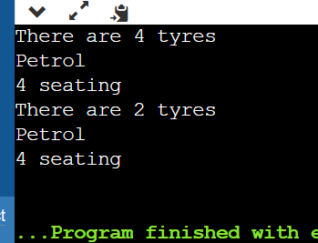

2) interface solution{

public void Hello();

public void Welcome();

public void Display(int i);

}

public class A implements solution{

public void Hello(){

java.lang.System.out.println("Hello World");

}

public void Welcome(){

java.lang.System.out.println("Welcome to Edureka");

}

public void Display(int i){

java.lang.System.out.println(i);

}

public static void main(String[] args ){

A a=new A();

a.Hello();

a.Welcome();

a.Display(4);

}

}

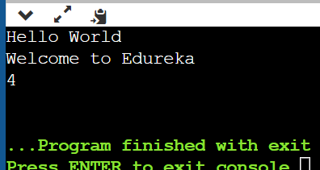

3)

interface Calculator{

public void Add(int a,int b);

public void Subtract(double a,double b);

public void Multiply(int i);

}

class A implements Calculator{

public void Add(int a,int b){

java.lang.System.out.println("Add is"+ (a+b));

}

public void Subtract(double a,double b){

java.lang.System.out.println("Subtraction is"+ (a-b));

}

public void Multiply(int i){

java.lang.System.out.println("Multiplication is"+ i*i);

}

public static void main(String[] args ){

A a=new A();

a.Add(2,5);

a.Subtract(3.5,2.1);

a.Multiply(4);

}

}

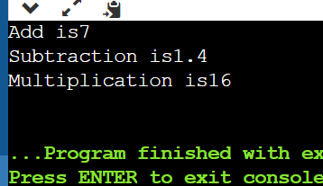

4) interface Machine{

public void start();

public void stop();

}

class Waterpump implements Machine{

public void start()

{

System.out.println("Starting Waterpump");

}

public void stop(){

System.out.println("Stopping Waterpump");

}

}

class Testing{

public static void main(String[] args ){

Machine m=new Waterpump();

paint(new Waterpump());

}

public static void paint(Machine m)

{

m.start();

m.stop();

System.out.println("Painting...");

}

}

5)